מטלה 1 – כתיבת דרישות בפורמט user story

**Job Search System:**

Job Search System is a system where candidates can look for jobs independently without the help of human resources agencies.

The system will be used by multiple users.

**Candidate (potential employees):**

1. **As a potential employee, I want to be able to login to the system using an ID and password so that I can use the system to search for potential jobs and apply to them.**
   1. Make a login system that ask for the id and password of the user, if it’s correct and exist in the system redirect to the menu of the candidate.

Display an error message if id or password isn’t correct.

1. **As a potential employee, I can register to the system using my personal details, ID and password so that I can use the system to search for potential jobs and apply to them.**
   1. Make a registration system that will ask each field one after the other of the personal details and the user will have to fill them by typing an input.
   2. Personal details include

- first name

- last name

- age

- location

- phone number

1. **As a potential employee, I can search and apply for jobs by different features so that I can better identify the right job for me.**
   1. Make a search system that will ask one by one the features that the user want and show all job offers that have those features included.

if a feature isn’t relevant / important for the potential employee he / she will be able to pick “none”.

* + 1. Features include

- full-time / half time position

- experience(years)

– profession

- location(region)

* + - 1. Supported professions in the system are:

- software engineer

- electrical engineer

- civil engineer

- mechanical engineer

- Industrial engineering and management

- chemical engineering

(7 options with no profession).

* + - 1. Supported experience(years) will be:

- 0 (no experience)

- 1

- 2

- 3

- 4

- 5+

(6 options).

* + - 1. Supported locations(regions) will be:

- Jerusalem region

- Northern region

- Haifa region

- Central region

- Tel-Aviv region

- Southern region (6 options).

* 1. Applying will work by asking the user for the uid of the job he / she wants to apply to and if the uid given is in the system, then it will apply.

If it isn’t in the system return an error message.

1. **As a potential employee, I can upload my resume to the site so that employers can see it in the system and have a better understanding on who I am and what are my qualities.**
   1. Make a system that after login into the system the user will have an option to add a resume in the menu.
      1. Resume will be a text file that is uploaded before on the computer and be able to read from it (as the system doesn’t have a server, we must upload the file before).
2. **As a potential employee, I can check my submission’s history to jobs so that I can see what their status is and what is the submission itself.**
   1. Make a list of submission history that will be in order of last submitted to first submitted and will be shown whenever asked.
   2. Status includes:

- Accepted

- Rejected

- Waiting for response

1. **As a potential employee, I can edit my profile so that I can update it if needed.**
   1. Make a system that will give 2 options of editing his / her profile after login on.
      1. First option is to edit its profile, and it will give it the option of changing its first name, last name, age, location and phone number each individually.
      2. Second option is to edit his / her resume.
2. **(Original) – As a potential employee, I can check what is the average payment for a profession so that I can check if the salary given is good.**
   1. Make a system that calculates the average for each profession and give an option to check each one.

Calculation will be based on current job listings in the system and calculated based on them for an average.

* 1. Potential employee will be given a menu to choose which profession to check the average payment.
     1. Supported professions in the system are:

- software engineer

- electrical engineer

- civil engineer

- mechanical engineer

- Industrial engineering and management

- chemical engineering

1. **(Original) – As a potential employee, I can chat with a bot for common questions and tips so that I can check common questions and upgrade my profile for a better chance of employment**
   1. Make a FAQ list of common questions and tips that whenever a question is chosen to show the answer for it.
      1. Common questions / tips in the system are:

Q1: Do I have to upload my resume to use this site?

A: No, it’s not required to upload your resume to use this site, but it’s recommended to make your profile more attractive for potential employers to employ you.

Q2: How do I find the right job for me?

A: By using the filters in the search option, you can find the right job for you.

Q3: Is there a way to search for a job without any experience?

A: Yes, you can search for jobs without any experience by filtering with 0 years of experience.

Q4: How do I apply to a job?

A: After searching you will be given a prompt if you want to apply for a job or not.

If yes, input the name of the submission / job and it will apply automatically.

Q5: How can I check the status of my submission?

A: In the main menu you have an option “submission history” click it and you will have information on all your history of submissions.

(more questions may be added in the future).

1. **(Original) – As a potential employee, I can post a review for an employer so that users can have more information on this employer.**
   1. Create a system that after login on you will be able to leave a review on an employer after login into the system (it will be one of the options in the menu).
      1. Potential employee will use first name and last name of employer to search for employer, if said employer is in the system it will prompt the user to leave a review if not it will give back an error message that the employer doesn’t exist.
   2. All reviews of an employer should be stored under said employer.
2. **(Original) – As a potential employee, I can delete my account if I want to leave the site completely so that my data doesn’t remain.**
   1. Create an option for user to delete the account completely from the data of the system after login onto the system (will be an option in the menu).
   2. All data includes his / her personal details and all applications to jobs.

**Employer:**

1. **As an employer, I want to be able to login to the system using an ID and password so that I can use the system to post my job offers so that potential employees can see them and join my business.**
   1. Make a login system that ask for the id and password of the user, if it’s correct and exist in the system redirect to the menu of the employer.

Display an error message if id or password isn’t correct.

1. **As an employer, I can register to the system using my personal details, ID and password so that I can use the system to post my job offers so that potential employees can see them and join my business.**
   1. Make a registration system that will ask each field one after the other of the personal details and the user will have to fill them by typing an input.
   2. Personal details include:

- first name

- last name

- age

- location

- phone number

1. **As an employer, I would be able to publish, delete and update a job submission so that I can manage my submissions.**
   1. Create a system that after login on the employer will be given a menu that he will be able to publish / delete / update a submission all separately.
      1. Publishing a job will ask to fill all the required fields (required fields are written in 3.2) and will be pushed to the system as part of all the jobs available.
      2. Editing a job will ask which field to edit and after choosing the relevant field the user will be asked to change it to the desired option.
      3. Deleting a job will ask to give the uid of the job to be deleted and after confirming it exist and is from this user will delete it.
   2. A job submission to the system include:

- Brief explanation of the job

- full-time / half time position

- experience(years)

- profession

- location(region)

- salary (salary is an optional field 0 will mean not specified)

- unique id (given automatically when created by the system)

* + 1. Supported profession in the system are:

- software engineer

- electrical engineer

- civil engineer

- mechanical engineer

- Industrial engineering and management

- chemical engineering

(7 options with no profession).

* + 1. Supported experience(years) will be:

- 0 (no experience)

- 1

- 2

- 3

- 4

- 5+

(6 options).

* + 1. Supported locations(regions) will be:

- Jerusalem region

- Northern region

- Haifa region

- Central region

- Tel-Aviv region

- Southern region

(6 options).

1. **As an employer, I can view all the job opportunities I published so that I can check all the jobs I have currently published to the system so that I can manage them better.**
   1. Make a system that shows all the jobs that the employer published from first job publish to last one.
      1. After login into the system the employer will be given the option to see his / her submissions (from the menu).
2. **As an employer, I can view the profile of the candidates who submitted their resume for a job I published so that I can accept or deny his / her application**
   1. Make a system that shows all the waiting applications for this specific employer and a show the profile of whoever applied with the option to accept or reject his / her submission.

If there is no submission give an according prompt.

1. **As an employer, I can search jobs by different features so that I can see what the situation of the market is to further improve my business and check the market situation.**
   1. Make a searching system that will work by asking the user for each feature one after another, if a feature isn’t relevant / important for the employer he / she will be able to pick “none”.
   2. Features include:

- full-time / half time position

- experience(years)

- profession

- location(region)

* + 1. Supported profession in the system are:

- software engineer

- electrical engineer

- civil engineer

- mechanical engineer

- Industrial engineering and management

- chemical engineering

(7 options with no profession).

* + 1. Supported experience(years) will be:

- 0 (no experience)

- 1

- 2

- 3

- 4

- 5+

(6 options).

* + 1. Supported locations(regions) will be:

- Jerusalem region

- Northern region

- Haifa region

- Central region

- Tel-Aviv region

- Southern region

(6 options).

1. **(Original) – As an employer, I can pay to advertise my submission so that more people can see my submission.**
   1. Create an advertisement system so that the employer will be given an option to advertise a submission after login on (as payment isn’t possible with our system the user will be given a prompt if he would like to pay, and he / she would be able to accept or deny).
   2. Advertisement prompt will be given in 2 instances:

First when publishing a job listing.

Second in the menu as an option after publishing.

* 1. Advertisement will work by passing the search system and always showing the submission even if they didn’t search with the same features.

(It will work with a bool statement true means paid advertisement and false means not paid advertisement).

1. **(Original) – As an employer, I can chat with a bot for common questions so that I can check common questions and upgrade my submission to make them more attractive.**
   1. Make a FAQ list of common questions and tips that whenever a question is chosen to show the answer for it
      1. Common questions / tips are:

Q1: Can I use the same account as an employer and a candidate?

A: No, each account has different features, so it is impossible.

Q2: How much time does it take after uploading a job to accept it to the system?  
A: Instantly, our system immediately uploads the submission to the jobs submissions.

Q3: How many jobs submission can I submit at the same time?

A: There is no limit.

Q4: How do I see the candidates that apply for my jobs?

A: In the menu, there will be an option to view profiles of candidates to accept / deny them.

Q5: Can I edit my submission after uploading it?

A: Yes, it is possible there is an option in the menu to edit submissions.

1. **(Original) – As an employer, I can delete my account if I want to leave the site completely so that my data doesn’t remain in the system.**
   1. Create an option for user to delete the account completely from the data of the system after login onto the system (will be an option in the menu).
   2. All data includes his / her personal details and all posted jobs.

**Nonfunctional tasks:**

1. Load - Maximum load on the system should be 1000 users at the same time.
2. Security - Use a security protocol to make sure accounts are protected from information being leaked or stolen.
3. Performance - The system should always be operational with minimal downtime.
4. Accessibility - The system should be able to work in multiple platforms with minimal changes for example pc and mobile.

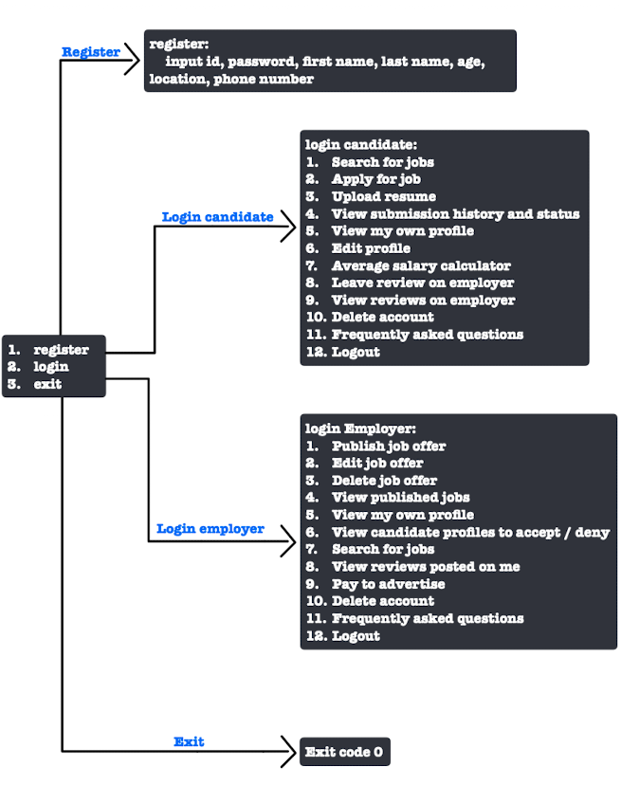**Basic concept:**